EXPERIMENT 18 : OPTICAL SPECTRUM AND OSNR ANALYSIS USING OPTISYSTEM

OBJECTIVES:
  - Design an optical communication system using OptiSystem.
  - Study how source power affects optical spectral intensity.
  - Analyze how fiber length affects attenuation, dispersion, and nonlinear effects.
  - Study the combined effect of source power and fiber length.

SOFTWARE USED : OPTISYSTEM SOFTWARE

CIRCUIT DIAGRAM:
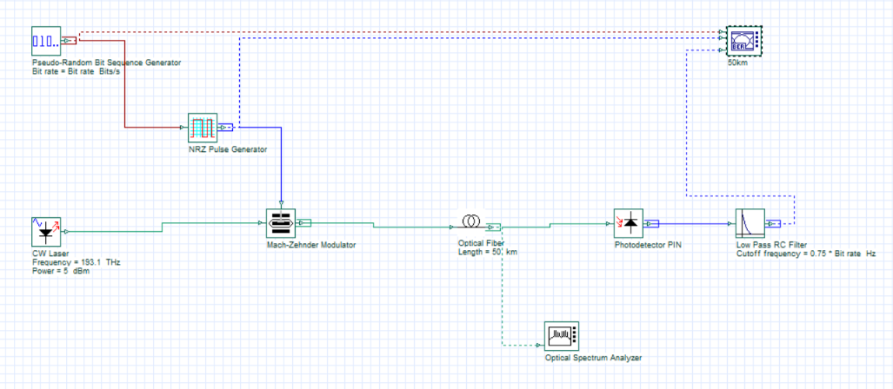
OUTPUTS:
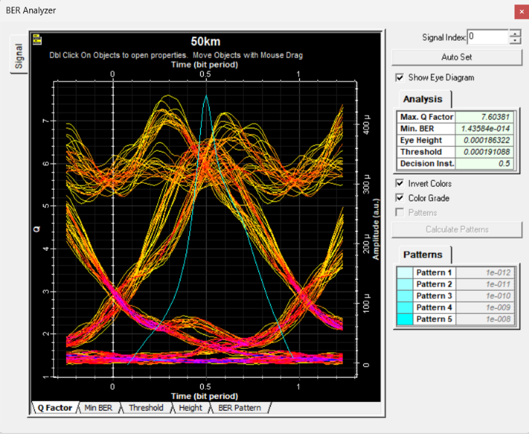 | 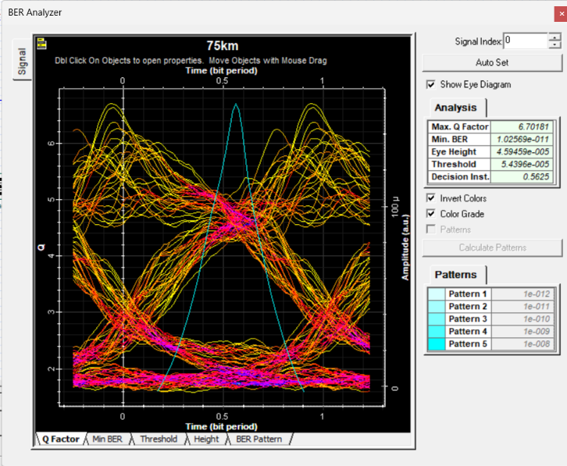
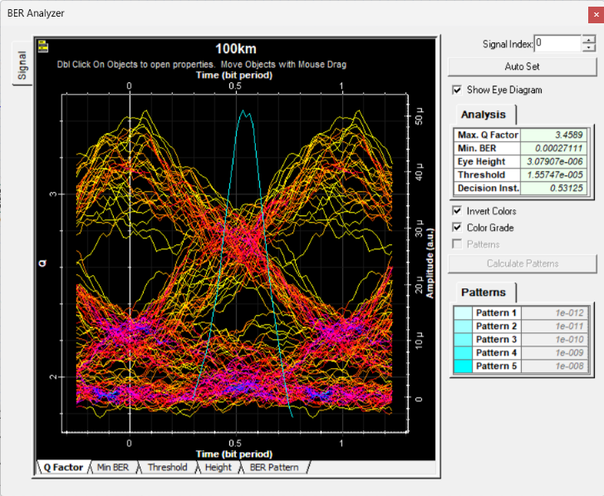 | 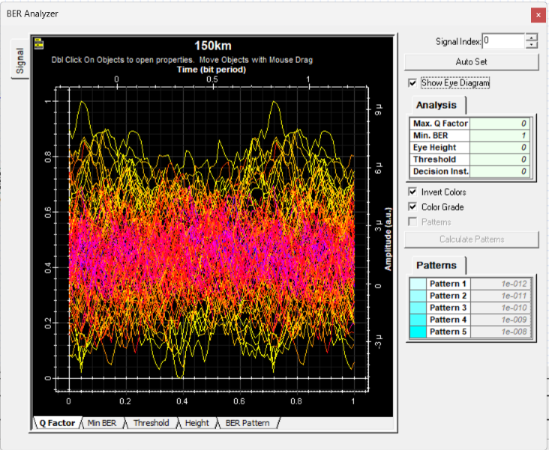

RELFECTION:
I learned to design and simulate an optical communication system using Optisystem and analyze the optical spectrum, BER, Q-factor at different source powers and fiber lengths.
I understood how attenuation, dispersion and nonlinear effects influence signal quality and identified suitable operating conditions for reliable optical transmission.
RUBRICS:
Objective | Assessment Criterion | Excellent – 4 | Good – 3 | Satisfactory – 2 | Needs  Improvement  – 1 | Weight age
System Design  & Simulation  Setup | Correct selection and connection of OptiSystem components (CW Laser, MZM,  PRBS, NRZ Pulse  Generator, SMF,  PIN Photodiode,  Low Pass Filter,  OSA, BER  Analyzer). | All optical and electrical  components are correctly selected, connected in proper sequence, and configured without errors. | All  components are present with minor layout or connection errors, but the simulation link remains functional. | Component selection is  partially complete; minor connection or configuration errors impede signal flow. | Incorrect component selection or improper setup leading to complete simulation failure. | 20%
Parameter  Configuration  & Execution | Accurate setup of physical input parameters: Wavelength  (1550 nm), Attenuation (0.2 dB/km), Dispersion (16 ps/nm/km), Source Power, and Fiber Length across all test cases. | All input  parameters and test cases (Test Cases 1, 2, and 3) are accurately set and executed per procedure. | Test case parameters are mostly accurate with minor setting discrepancie  s. | Basic parameters are configured, but one or more  test case parameter variations are missing. | Incorrect input parameter settings or failure to run the required test cases. | 20%
Measurement  & Data  Collection | Accurate extraction and recording of Min BER, Max Q-  factor, spectral power, and eye diagram displays. | Precise data extraction across all test cases, neatly tabulated with complete optical spectra and clear eye diagrams. | Data is collected with minor omissions in recording BER, Q-  factor, or spectral readings. | Partial data collection with incomplete tables or missing eye diagram readings. | Inaccurate, incomplete, or missing data  and measurements  . | 20%
Data Analysis  & Spectral  Interpretation | Detailed evaluation of source power impact, fiber length attenuation, dispersion, and non-linear distortion on link performance. | Comprehensive  analysis correctly relating source power and length variations to spectral broadening, attenuation, dispersion, BER, and Q-factor degradation. | Clear analysis identifying basic trends in BER and Q-factor relative to  power and distance variations. | Basic attempt at result analysis without explaining physical mechanisms like dispersion or non-linearity. | Erroneous or missing analysis of simulation results and graphs. | 20%
Report & Conclusion | Logical deduction of optimal operating parameter range, visual presentation of output graphs, and structural clarity. | Report features clear graphs, complete tables, and insightful conclusions identifying optimal parameters for peak Q-factor and lowest BER. | Satisfactory report with relevant graphs and sound concluding summary. | Incomplete report with missing graphs,  eye diagrams, or weak conclusions. | Disorganized or incomplete report lacking required diagrams and valid conclusions. | 20%

CONCLUSION:
The optical spectrum was successfully analyzed using OptiSystem. Higher source power increased spectral intensity and caused nonlinear broadening, while longer fiber length led to greater asenuation and dispersion. Together, these effects increased spectral distortion and signal degradation.

